**Lab - Exploring DNS Traffic**

Part 2: Explore DNS Query Traffic

d. Expand Ethernet II to view the details. Observe the source and destination fields.

What are the source and destination MAC addresses? Which network interfaces are these MAC addresses associated with?

Answer: The source MAC address is associated with the NIC on the PC and the destination MAC address is associated with the default gateway. If there is a local DNS server, the destination MAC address would be the MAC address of the local DNS server.

e. Expand Internet Protocol Version 4. Observe the source and destination IPv4 addresses.

What are the source and destination IP addresses? Which network interfaces are these IP addresses associated with?

Answer: The source IP address is associated with the NIC on the PC and the destination IP address is associated with the default gateway.

f. Expand the User Datagram Protocol. Observe the source and destination ports.

What are the source and destination ports? What is the default DNS port number?

Answer: The source port number is 577729 and the destination port is 53, which is the default DNS port number.

g. Determine the IP and MAC address of the PC.

1) In a Windows command prompt, enter arp –a and ipconfig /all to record the MAC and IP addresses of the PC.

2) For Linux and macOS PC, enter ifconfig or ip address in a terminal.

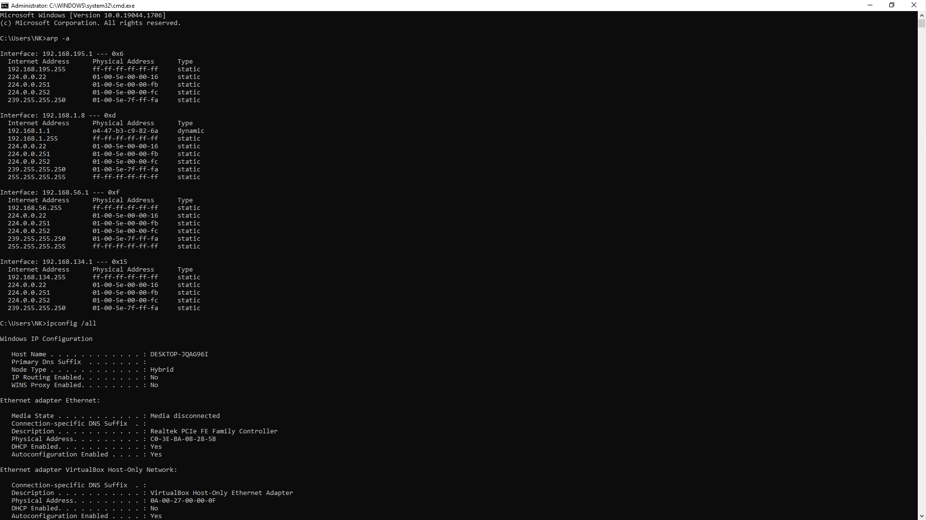 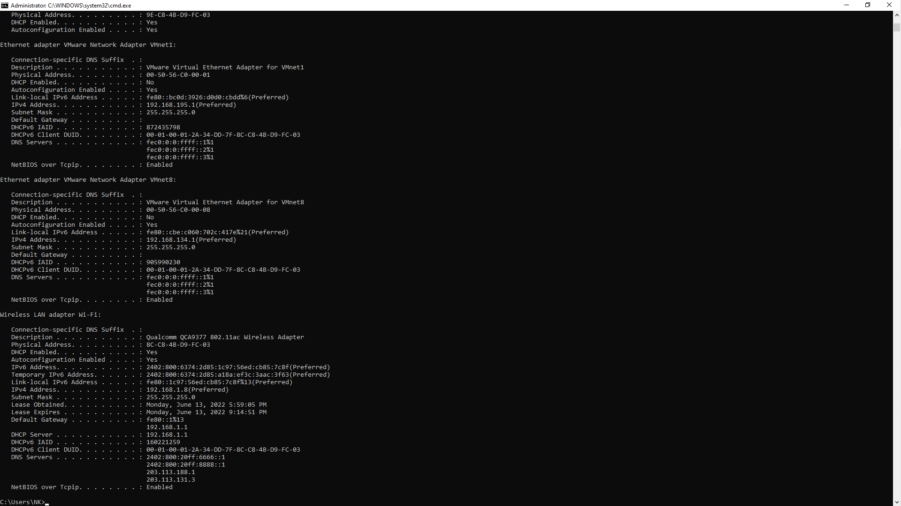

Question: Compare the MAC and IP addresses in the Wireshark results to the IP and MAC addresses. What is your observation?

Answer: The IP and MAC addresses captured in the Wireshark results are the same as the addresses listed in ipconfig /all command.

h. Expand Domain Name System (query) in the Packet Details pane. Then expand the Flags and Queries.

i. Observe the results. The flag is set to do the query recursively to query for the IP address to [www.cisco.com](http://www.cisco.com).

